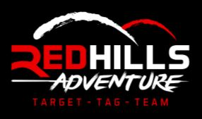
Splatmaster, Archery Tag, Teambuilding, Assault Course
(The following also relates to all activities offered by Redhills Adventure Ltd)
PARENTAL Disclaimer (on behalf of participating child)
1 I shall at all times conform to the Safety Rules as set out in the instructor briefing on the day and any further instructions or additional rules laid out by the staff. I will respect the instructor’s requests and abide by their decisions
2 For tag/ target activities, I will wear my MASK/ EYE PROTECTION at all times while in the game zones. Removal of MASKS/EYE PROTECTION in game zones will result in removal from the activity without refund
3 Redhills Adventure uses Garda Vetted and trained instructors. All our activities are strictly supervised and we are experienced in dealing with large groups and young children. In the unlikely event that a child is being unsafe to themselves or others, causing disruption to the group as a whole or being rude or difficult with staff, the management reserves the right to remove any child from the activity and no refund will be offered
4. I agree that all equipment provided to me will be returned undamaged. Damaged equipment due to misuse or missing equipment may incur a charge
5 I undertake not to hold the proprietor Redhills Adventure Ltd., liable for any injury, loss or damage which I might sustain whilst participating in activities at Redhills Adventure Ltd.
6 For marketing purposes we occasionally take pictures of groups or record videos of activities. Please tick the following box if you do not consent to point 6
PLEASE PRINT CLEARLY AND IN CAPITALS:
Mobile Number Parent |
Name of Child |

Medical Conditions if any |
Signature of Parent |
Date of Event |
Date of Birth of child |

